CSA 283: Final

Name: ______________________________________ Section: _____ _____

- Write legibly and use a pencil.
- Ask questions if something is unclear.
- Write down any assumptions you make.
- The exam is printed on both sides of the page.
- Keep your answers concise. Write the minimum that is necessary when explaining.
- During the programming portion of the exam you may have access the Java API at:

http://download.oracle.com/javase/1,5.0/docs/api/

- Consider the network diagram shown in the supplemental handout. The diagram depicts the following:

- Four end systems labeled A, B, C, and D
- Two switches labeled S1 And S2
(Switch interfaces are labeled 1, 2 and 3 for each switch)
- Five routers labeled R1, R2, R3, R4, and R5.
  - The interfaces of R2 are labeled 1, 2, and 3
  - Router R1 is performing NAT

Information held at various nodes is given in tables on the page attached to the diagram.

Use the diagram and tables to answer the following questions. Write no more than one sentence for “Why or Why not?” questions.

Consider a message being sent from host A to host C and the segments, datagrams, and frames that will be generated to carry the message.
- The socket on A that is being used to send messages has a port number of 5600.
- The port number of the socket being used on C to receive the message is 80.

    - Assuming it was not manually set, what protocol would you expect A to use to obtain and IP address? (4 points)

    - The MAC address of interface card used by C is 77-2A-F1-53-41-04. How/when is this address normally obtained? (5 points)

    - Suppose A knows the name of computer C is www.netnews.com. What protocol would A use to determine the IP address of C? (4 points)

    - What protocol would A use to determine the MAC address of C? (3 Points)

    - Based on the information shown to be held by A, can A put together a frame that will be received by R1? Why or why not? (4 points)

    - If you answered no to the previous question, describe the process that would take place before A could construct a frame to send to R1.
(4 points)

    - When A is sending a packet to C, will the network interface adapter of B receive the frame that is sent by A to R1? Why or why not? (4 points)

    - When A is sending a datagram to C, what will be the destination IP address and port number in the datagram/segment as it travels between A and R1? (4 points)

Destination IP ____________________________________

Destination Port ____________________________________

    - When a datagram travels from A to C, what will the source and destination physical addresses be in the frame that carries it from A to R1? (4 points)

Source MAC: ____________________________________

Destination MAC: ____________________________________
    - When A is sending a datagram to C, what will be the source IP address and port number in the datagram /segment as it travels between A and R1? (4 points)

Source IP ____________________________________

Source Port ____________________________________

    - When a datagram travels from A to C, what will the source and destination physical addresses be in the frame that carries it from R1 to R2? (4 points)

Source MAC: ____________________________________

Destination MAC: ____________________________________

    - Based on the forwarding table given for R2, when A is sending a packet to C, will it forward the packet to R3 or R4? (4 points)

    - Approximately how many hosts could the first subnet identified by forwarding table of R2 contain? (4 points)

    - When A is sending a datagram to C, what will be the source IP address and port number in the datagram /segment as it travels between R5 and C? (4 points)

Source IP ____________________________________

Source Port ____________________________________

    - When A is sending a datagram to C, what will be the destination IP address and port number in the datagram /segment as it travels between R5 and C? (4 points)

Destination IP ____________________________________

Destination Port ____________________________________

    - When a datagram travels from A to C, what will the source and destination physical addresses be in the frame that carries it from R5 to C? (4 points)

Source MAC: ____________________________________

Destination MAC: ____________________________________

    - Based on the information shown to be held by R5, can R5 put together a frame that will be received by C? Why/ why not? (4 points)

    - If you answered no to the previous question, describe the process that would take place before R5 could construct a frame to send to C.
(4 points)

    - Would R5 need to use ARP to find the MAC address of S1? Why/why not?(4 points)

    - When R5 is sending a frame to C, will the interface adapter of D receive the frame? Why/why not? (4 points)

    - Can R5 transmit a frame to C via S2 while D is transmitting a frame to R5 via S2 without colliding? Why or why not? (4 points)

    - Suppose S2 was a hub instead of a switch. Would R5 be able transmit a frame to C via S2 while D is transmitting a frame to R5 via S2 without colliding?? (3 points)

    - After R5 has sent a frame to C, would the switch table for S2 be updated? If so what entries would be added to the switch table? (4 points)

    - Suppose the subnet containing R5 and C has a MTU of 580 bytes. Further suppose the original datagrams sent by A have a length of 2570 bytes. What would R5 do with the datagrams sent by A? (4 points)

    - If C sends a reply back to A, what will the source IP address and source port number be in the datagram/segment as it travels between C and R5? (4 points)

Source IP ____________________________________

Source Port ____________________________________

    - If C sends a reply back to A, what will be the destination IP address and port number in the datagram/segment as it travels between R2 and R1? (4 points)

Destination IP ____________________________________

Destination Port ____________________________________

    - In what way will the IP addresses of C, D, and the R5 adapter with a MAC address of 51-3D-CA-CD-04-0C be related? Why?(5 points)

    - If R3, R4, and the R5 are controlled by different organizations, would you expect them to use the same Intra-AS Routing protocol? Why or why not? (5 points)

    - How will the MAC addresses of A, B, and the R1 adapter with a MAC address of 51-1B-24-55-AF-06-34 be related? (4 points)

    - Based on the diagram, how many subnets does R5 belong to? (4 points)

  - Write the appropriate Internet protocols (acronyms are fine):

    - Name the primary public domain network layer protocol used in the Internet. (4 points)

___________________________

    - Name the two primary public domain transport layer protocols used in the Internet?
(6 points)

___________________________ ___________________________

    - Name the primary public domain data link and physical layer protocol used in the “wired” Internet? (4 points)

___________________________

    - Name one public domain application layer protocol used to support email and one public domain application layer protocol used to support the World Wide Web in the Internet. (6 points)

___________________________ ___________________________

  - Why do collisions occur when a Carrier Sense Multiple Access (CSMA) protocol is used? Write no more than two sentences. (5 points).
  - Give definitions for the following terms using one or two sentences. If the term is an acronym, also state what the letters in the acronym stand for and give a definition. Use no more than two sentences to describe the term.

a. MAC Protocol (6 points):

b. Virtual Circuit(6 points):

c. Overlay Network (6 points):

d. Demultiplexing (6 points)

e. Elastic Application (6 points)

  - Show how the RIP protocol would update A’s forwarding table after the given the advertisement is received from B. (24 points)

- Routers are identified by upper case letters i.e. A, B, C, D, E, etc.

- Subnets (destinations) are identified by lower case letters i.e. s, t, u, v, w, y, z.

- The neighbors of a router are one hop (one subnet) away.

The following is the routing table at router A:

Destination Subnet | Next Router | Number of Hops to Dest.
s | B | 4
t | G | 3
u | - | 1
v | B | 4
w | D | 3
y | G | 5

Assume that router A receives the following advertisement from neighbor B:

Destination Subnet | Next Router | Number of Hops to Dest.
k | O | 3
s | R | 4
t | - | 1
u | - | 1
y | Q | 9
z | F | 4

As a result of the above advertisement, A may (or may not) change its routing table. Show A’s updated routing table below:

Please list the destinations in alphabetical order.

Destination Subnet | Next Router | Number of Hops to Dest.

  - Consider the following scenario:

An application running on smtp.cnn.com needs to determine the IP address of mail.whitehouse.gov in order to make a TCP connection. In the following, assume that all nodes cache DNS records and that all DNS caches at present only contain the minimum information necessary to function following initialization. DNS server names are as follows:

Top Level Domain DNS server, gov: dns.tld.gov
Top Level Domain DNS server, com: dns.tld.com
Local Name server, whitehouse: local.whitehouse.gov
Local Name server, cnn: local.cnn.com
Authoritative DNS, cnn: adns.cnn.com
Authoritative DNS, whitehouse: adns.whitehouse.gov
Root DNS server: dns.root

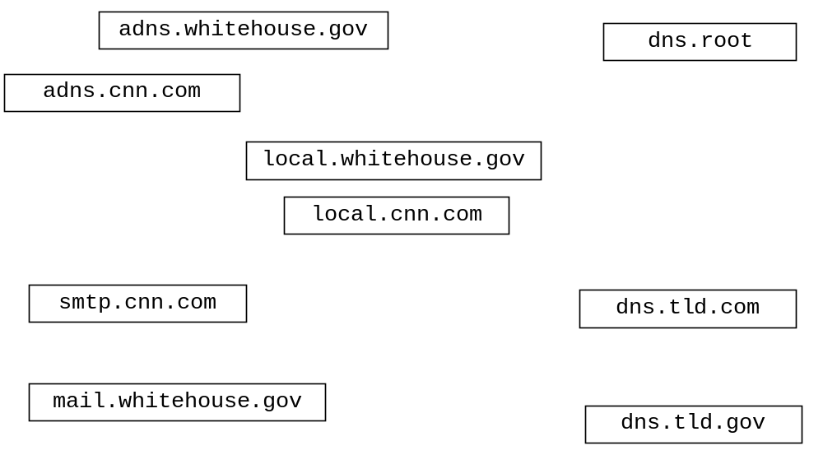Draw arrows labeled with numbers to indicate the order of queries and responses sent before smtp.cnn.com receives the IP address of mail.whitehouse.gov. The first query sent by smtp.cnn.com is handled recursively. Assume all other queries are handled iteratively. (24 points)
  - Complete the TCP TicTacToeServer on the following page. Do not worry about handling exceptions. Allow the main method to throw them to the OS. The state of the game is maintained in an object of the TicTacToeGame class which allows a human to play against a computer; see page three of supplemental handout. (40 points)
- After connecting, clients send moves by sending the row and column of a selected square as ints using TCP. Clients always move first.
- Each time a move is received the server passes it to makeMove and sends the value returned by makeMove to the client using TCP.. Depending on the returned value, the server then does the following.
  - If the game is not over or the computer has won, the server calls getMoveRow and getMoveCol and sends the two returned values using TCP. to the client.
  - If the game is over due to either the computer wining or the player winning or if a draw has occurred, the server closes all streams and sockets associated with the client are returns to a state where it is waiting to accept a connection from another client so it can play a new game.
- If both the row and column sent by the client are negative, the server immediately closes all streams and sockets associated with the client are returns to a state where it is waiting to accept a connection from another client so it can play a new game.
- The Server listens on port number 7777.
- The Sever is single threaded. The Server never closes.

  - Complete the UDP TicTacToeClient class on the last page of the exam. Do not worry about handling exceptions. Allow the main method to throw them to the OS. (40 points)
- Clients always go first.
- Clients query a user for a row and column index of a selected square in tic-tac-toe.
- Clients send moves to the server in a single datagram containing two ints using UDP.
- Following each move the server replies by sending a single datagram using UDP containing up to three ints. The first int is a code indicating the state of the game.
  - If the code sent by the server is a 10, the game is not over. Two additional ints in the datagram contain the row and column of the square selected by the server. The client should print the row and column selected by the sever to the console.
  - If the code sent by the server is a 20, a draw has occurred, and the game is over. No additional ints are contained in the datagram.
  - If the code sent by the server is a 30, the move sent by the client resulted in a win, and the game is over. No additional ints are contained in the datagram.
  - If the code sent by the server is a 40, the game is over, and the server has won. Two additional ints in the datagram contain the row and column of the square selected by the server. The client should print the row and column selected by the sever to the console.
- If the user ever enters two negative numbers, the clients sends the number in a single datagram using UDP and then closes all open streams and sockets and exits.
- Whenever the game ends, the client prints “game over” and closes all open streams and sockets before exiting.
- The Server listens on port number 7777.
public class TicTacToeServer {

ServerSocket serverSocket;

TicTacToeGame game = new TicTacToeGame();

public static void main(String[] args) throws IOException {
new TicTacToeServer();
}

public TicTacToeServer() throws IOException{
public class TicTacToeClient {

Scanner console = new Scanner( System.in);

public static void main(String[] args) throws SocketException {
new TicTacToeClient();
}
public TicTacToeClient() throws SocketException
{

